**Roll No. 16010421055**

**Batch No. IT G3**

**Name: Minank Singh Mehta**

**Experiment No. 10**

**Title: Analysis of IR spectrum.**

**Aim:** To analyze the IR spectrum.

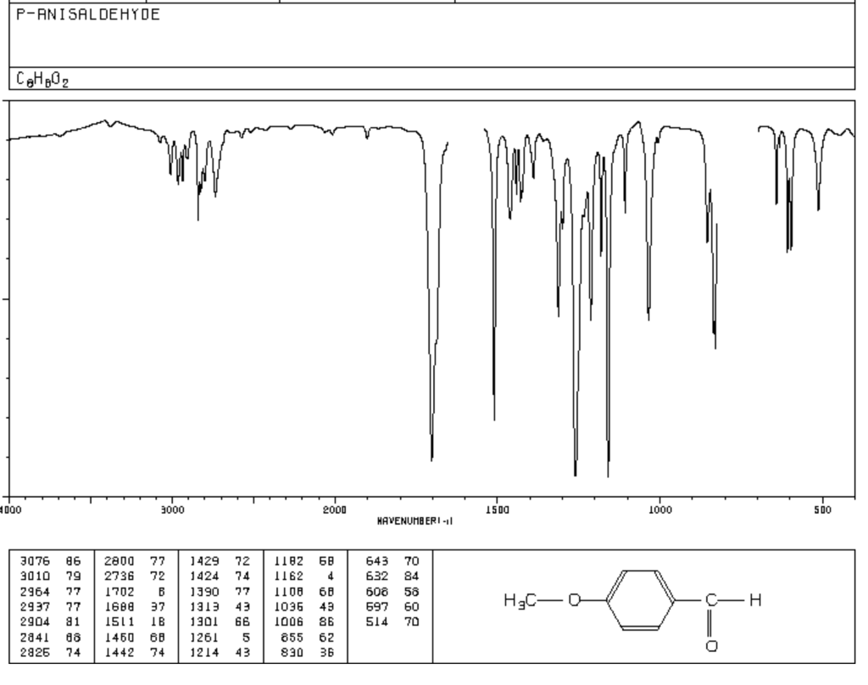

**Result:** Important IR frequencies of above compound are:

|  |  |  |  |
| --- | --- | --- | --- |
| **IR frequency**  **(cm-1)** | **Vibrational Type & Intensity** | **Frequency Range**  **(cm-1)** | **Functional Group** |
| 1424, 1429, 1442, 1450 | Medium-weak, Multiple Bands | 1400-1600 | Aromatic C = C |
| 1688, 1702 | Strong, stretch | 1670-1820 | Carbonyl C = O |
| 2736, 2800, 2826, 2841 | medium, two peaks, stretch | 2820-2850 & 2720-2750 | Aldehyde = C-H |
| 2904, 2937, 2964 | Strong, stretch | 2850-3000 | -C-H sp3 |

**Observations:**

* The number of atoms in C8H8O2 =18.
* The molecule is Non-linear.
* Therefore, the total number of Vibrational modes = 3N - 6 = 3(18) - 6 = **48.**

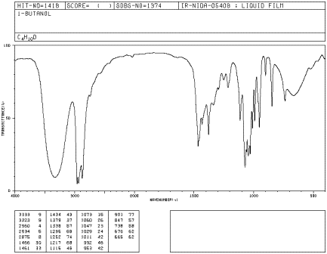

**Result:** Important IR frequencies of above compound are:

|  |  |  |  |
| --- | --- | --- | --- |
| **IR Frequency** | **Vibrational Type & Intensity** | **Frequency Range** | **Functional Group** |
| 3223, 3253 | strong, broad | 3200-3600 | O-H (stretch,  H-bonded) |
| 2950, 2934, 2875 | Strong, stretch | 3000-2850 | C-H Alkane |
| 1378, 1434, 1461, 1466 | variable, bending | 1350-1480 | -C-H Alkane |
| 1378, 1434, 1461, 1466 | variable, bending | 1350-1480 | -C-H Alkane |

**Observations:**

The molecule has formula H3C-CH2-CH2-CH2-OH.

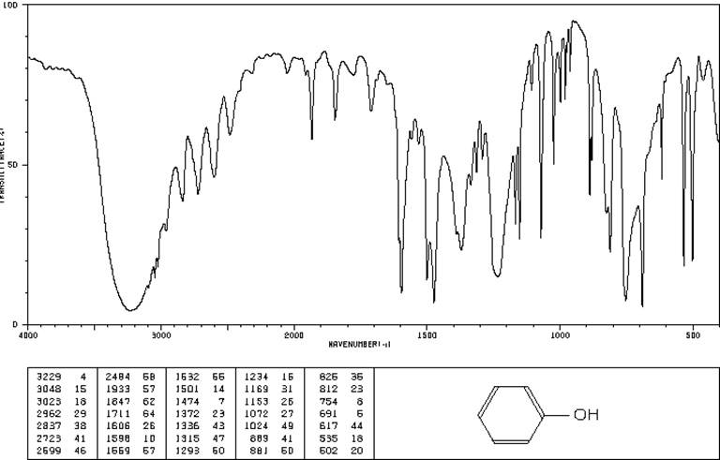

**Result:** Important IR frequencies of above compound are:

|  |  |  |  |
| --- | --- | --- | --- |
| **IR Frequency** | **Vibrational Type & Intensity** | **Frequency Range** | **Functional Group** |
| 3023, 3048 | medium, stretch | 3000-3100 | C-H (aromatic) |
| 1072, 1153, 1169 | Variable, bending | 1050-1150 | C-O (alcohol) |
| 1474, 1501 | medium-weak, multiple bands, stretch | 1400-1600 | C = C aromatic |
| 3229 | strong, H-bonded, stretch, free | 3200-3600 | O-H alcohol |

**Observations:**

* The number of atoms in C6H5OH = 13.
* The molecule is Non-linear.
* Therefore, the total number of Vibrational modes = 3N - 6 = 3(13) - 6 = **33.**

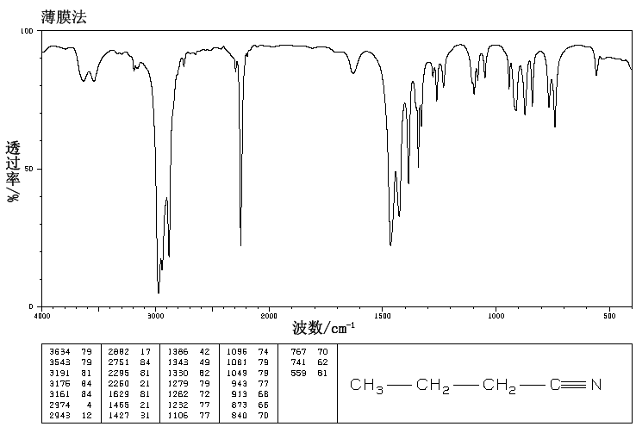

**Result:** Important IR frequencies of above compound are

|  |  |  |  |
| --- | --- | --- | --- |
| **IR Frequency** | **Vibrational Type & Intensity** | **Frequency Range** | **Functional Group** |
| 2882, 2943, 2974 | strong, stretch | 2850-3000 | C-H alkane |
| 2260 | medium, stretch | 2210-2260 | CN nitrile |
| 1343, 1386, 1427, 1465 | variable, bending | 1350-1480 | -C-H alkane |

**Observations:**

* The number of atoms in C4H7N = 12.
* The molecule is linear.
* Therefore, the total number of Vibrational modes = 3N - 5 = 3(12) - 5 = **31.**